Water Quality Monitoring System for Dhule Region using IOT

Sachin Kamble

*Department of IT*

*SVKM’s Institute of Technology* Dhule,Maharashtra, India

Parag Nikam

*Department of IT*

*SVKM’s Institute of Technology* Dhule,Maharashtra, India

Ruby Mandal

*Department of IT*

*SVKM’s Institute of Technology* Dhule,Maharashtra, India

Snehal Nikam

*Department of IT*

*SVKM,s Institute of Technology* Dhule,Maharashtra, India

Sreepriya K

*Department of IT*

*SVKM’s Institute of Technology* Dhule,Maharashtra, India

Akshay Patil

*Department of IT*

*SVKM’S Institute of Technology* Dhule,Maharashtra, India

***Abstract - In the face of increasing contamination and pollution of drinking water, a significant threat to both human health and ecosystem stability emerges. Waterborne diseases have the potential to disrupt the delicate balance of ecosystems. Timely detection of water contamination is essential to prevent harmful consequences. To ensure the delivery of clean water, continuous real-time water quality monitoring is imperative. The demand for intelligent solutions to monitor water contamination is escalating with the advancements in sensor technology, connectivity, and the Internet of Things (IoT). This research delves into a comprehensive exploration of the latest developments in intelligent water pollution monitoring systems. The study advocates for an IoT-based smart water quality monitoring system, which offers both cost-effectiveness and efficiency. The integrated model undergoes testing with water samples, and the parameters are transmitted to a cloud server for further analysis.***

***Keywords - Arduino Uno, pH sensor, turbidity sensor, Wi-Fi Module.***

INTRODUCTION

Water exerts an indescribable influence on all living organisms. The management of water resources is emerging as an increasingly pressing concern, particularly in the face of rapid global population growth, with specific ramifications for sectors such as industry and agriculture. Access to safe drinking water remains a challenge for a significant portion of the world's population, resulting in numerous fatalities from waterborne diseases annually. Research has consistently demonstrated that the consumption of contaminated water is the leading cause of approximately 5 million deaths each year. Furthermore, investigations carried out by the World Health Organization (WHO) have shown that ensuring children have access to clean drinking water could prevent more than 1.4 million child fatalities. In the realm of water quality monitoring systems, the 2023 paper titled "A Novel Sensor-based Water Quality Monitoring System using Internet of Things (IoT)" stands as a pioneering work. This paper offers a comprehensive discussion on the integration and harmonization of various migration theories within the domain of water quality monitoring. The focal point of this research is a Smart Water Quality Monitoring (SWQM) device capable of discerning distinct physical water characteristics, specifically pH and turbidity. These parameters are evaluated using well-suited machine learning techniques.[1][2] The foundation of this IoT-based Smart Water Quality Monitoring system comprises a network of sensors, including those designed for measuring pH and turbidity. These sensors are strategically deployed at key junctures in the water system, encompassing locations like reservoirs, treatment facilities, and distribution systems, where they consistently collect data. Subsequent to data acquisition, a microcontroller or processor, such as an Arduino, undertakes the critical task of digitizing analog sensor data. This digitized data is then relayed to a cloud-based platform for further analysis. All these new advancement in various applications allows more machines to be more intelligent and more easily accessible from

various remote locations. Also, the ability to share information and keep track of the changes in various fields helps to avoid future unexpected problems. In various applications and fields, the main principals and models of Industry 4.0 has found its way. All the systems which are equipped with the Internet of Things (IoT) capabilities can be adopted in the new industry models. This Internet of Things (IoT) helps to connect with a cloud environment. As a result, we can send and store data and connect different devices remotely. Also, with IoT we can integrate different types of sensors and devices to collect various types of data. Later this collected data can be used to compare with the decisions which are already has been loaded to a database. With the help of the IoT it will be easier to monitor and improve the sustainability of the environmental resources in an optimized way, and in this case, it is water source. As the aquaculture industry is growing rapidly and technologies are getting more advanced, various quality of water like turbidity ,pH, temperature are becoming most important factors to be monitored and measured. Like, the growth of fish gets affected by the quantity of dissolved oxygen in waterand this quantity is less in warm water compared to cold water[4,5]

LITERATURE REVIEW

In the twenty-first century, human life has become more easier and safer because of numerous advances in various technological fields. But at the same time various urban development, poorly designed sewage systems, radioactive and industrial wastes, the oil spills caused by offshore drilling, and various other forms of pollution are forming day by day, and because of this, the quantity of safe drinking water is reducing day by day. In present days various factors like exponential population growth, increasing water scarcity, groundwater pollution, and because of other factors water quality monitoring in real-time is more required. As a result, monitoring water quality metrics in real-time need better approaches [1].We measure the acidic or alkaline nature of water by pH metric and this scale ranges from 0 to 14[1].Pure water has a pH metrics of 7[1], which is neutral in nature. Safe drinking water should have pH metrics between 6.5 and 8.5 ph. Water clarity is measured by the turbidity scale. Higher turbidity means there are more unseen and suspended particles are present in water, which increases the chances of diarrhea, cholera, etc. diseases caused by polluted water. If the turbidity is low or in a safe range, then the water is safe to drink. Wireless communication is getting more and more common and helping people in their daily life and duties. Also, because of Industry 4.0 various new advanced and more optimized technologies are getting introduced[1].All these new advancement in various applications allows more machines to be more intelligent and more easily accessible from various remote locations.Also, the ability to share information and keep track of the changes in various fields helps to avoid future unexpected problems. In various applications and fields, the main principals and models of Industry 4.0 has found its way. All the systemswhich are equipped with the Internet of Things (IoT) capabilitiescan be adoptedin the new industry models. This Internet of Things (IoT) helps to connect with a cloud environment. As a result, we can send and store data and connect different devices remotely. Also, with IoT we can integrate different types of sensors and devices to collect various types of data. Later this collected data can be used to compare with the decisions which are already has been loaded to a database.With the help of the IoT it will be easierto monitor and improve the sustainability of the environmental resources in an optimized way, andin this case, it is water source. As the aquaculture industry is growing rapidly and technologies are getting more advanced, various quality of water like turbidity,pH, temperature are becoming most important factors to be monitored and measured.Like, the growth of fish gets affected by the quantity of dissolved oxygen in waterand this quantity is less in warm water compared to cold water[1].

PROPOSED METHOD

The sensors that measure various water quality parameters like pH and turbidity are the first part of the IoT- based smart water quality monitoring system. These sensors are integrated into the water system at several points, such as a reservoir, treatment facility, or distribution system, and they continuously gather data. The concepts mentioned in the paper were: -- SNEHAL & AKSHAY

A. Minimum and Maximum range of turbidity

B. Minimum and Maximum range of pH

C. Range

D. Arduino Uno

E. Turbidity sensor

F. PH sensor

G. Wi-Fi module

The systems primary scope should be clearly defined that it could be ensure the safety of safe drinking water. In the proposed system,the water quality will be checked by various sensors which are connected to the node MCU. The code is embedded into the node MCU by which all the sensors and model will work. The most essential water parameters needed to be monitored by the user are water turbidity, water temperature and water PH level and we are used these sensors mandatorily to monitor the quality of water. Temperatuire is measured using thermometer and turbidity is measured by using turbimeter. We have set the appropriate range of all the sensors which are preferable for safe drinking water.

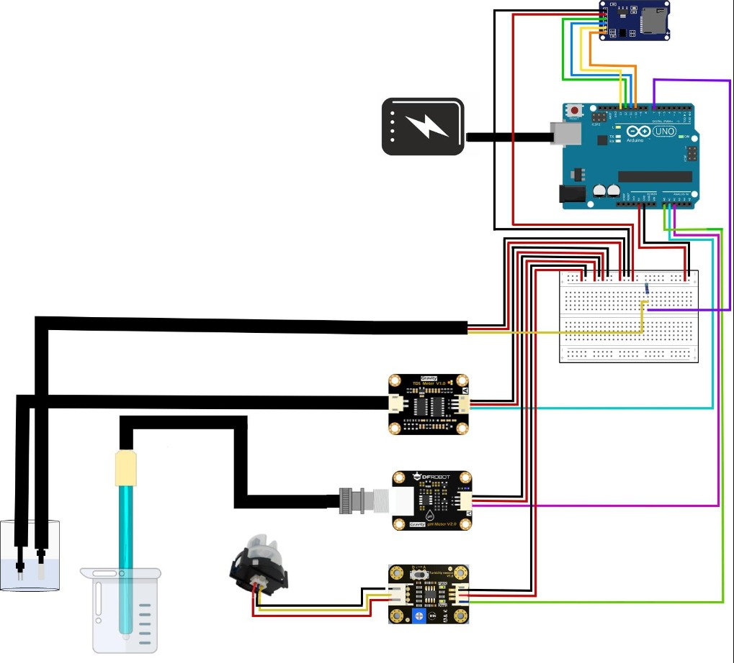

Fig. 1. Architecture diagram for IoT based Smart Water Quality Monitoring System

In the proposed system, the result that is water is portable or not can be shown on LED display which is connected to the Arduino UNO.

Data is wirelessly transmitted to an online server via wi-fi module. All the sensors are precisely calibrated for accuracy. Arduino UNO check readings against predefined limits. This system can take continuous measurement of water parameters when we use it.

The process of programming various sensor modules becomes easy and time saving with the help of this microcontroller.. But Arduino Mega does not have inbuild wireless module, so they have to use NodeMCU to enable wireless data transfer. This can cause propagation delay while transmitting large amount of data to the cloud server. To resolve this issue our proposed model uses Raspberry Pi microcontroller which have inbuild wireless model. This helps to reduce propagation delay as data from raspberry pi can get transmitted directly to the server. To monitor transmitted data in real time from remote places we need a IoT cloud space which will fetch various data from sensor nodes in real time. To enable this real time data monitoring the proposed system utilizes cloud database which will store and fetch data transmitted from sensor nodes and user can monitor the data in real time.

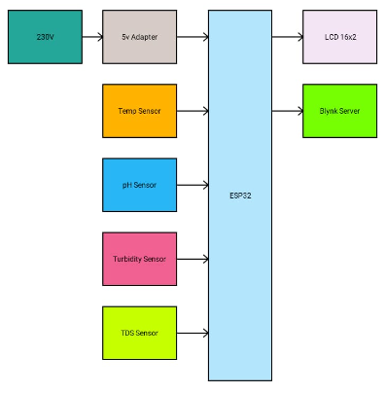

Fig. 1. Block diagram for IoT based Smart Water Quality Monitoring System

This model, based on data mining techniques, aids in the prediction of clean water sources. The research aimed to develop a predictive model capable of identifying water samples necessitating further laboratory analysis, thus optimizing the workflow for laboratory technologists.

To implement the model, WEKA software was utilized [4,10,15] leveraging secondary data collected from the Kenya Water Institute. The decision tree algorithm was applied to classify water samples into two categories: clean and contaminated. The research emphasized the significance of water alkalinity and conductivity as critical factors in evaluating water quality, emphasizing their paramount importance for public health and safety. The study also evaluated the model's accuracy using five distinct decision tree classifiers: J48, LMT, Random Forest, Hoeffding Tree, and Decision Stump [8] The specific threshold ranges for each sensor are initialized before the system starts operating. The specified ranges and values are as follows:

A. pH Sensor

pH value ranges from 0 to 14. A pH level below 7 is acidic and above than 7 is alkaline. The neutral pH level is 7. According to WHO, 6.5-8.5 pH levels are safe for water drinking [4].

B. Turbidity Sensor

The turbidity should not exceed 5 NTU (Nephelometric Turbidity Unit) [4]

C. Total Dissolved Solids Sensor

The average water range that safe water drinking guidelines have approved is 50-150 ppm (parts per million) [4].

D. Temperature Sensor

The expected water temperature is 25 Celsius but in the range of 24-30 Celsius are acceptable.

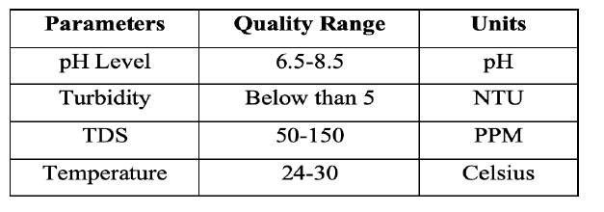

Fig. 2. Parameters IoT based Smart Water Quality Monitoring System Source [5]

Five samples were collected from different water sources and tested to measure parameters such as pH, temperature, TDS, and turbidity for each sample. Each water sample will be tested five times on consecutive days to obtain accurate values for all four physical parameters. The average of each parameter is important for the system to predict whether it is drinkable or not. pH sensor results were collected daily for five days. The highest pH of the tap water was 7.7 on day 5, and the lowest was 7.1 on day 1. The second water sample is coway water, the pH of the filtered water is almost neutral. The highest pH in the third test was 7.1, and the lowest pH in the first test was 6.8. The pH of river water is relatively high, with a maximum of 8.3 and a minimum of 7.8. The pH of pond water is not much different from tap water. The most elevated pH was 7.7, and the lowest was 7.3. The lake water is moderate, with a maximum pH of 7.8 and a minimum pH of 7.5. Based on the five-day results shown in Table II, the water samples tested did not fall outside the threshold range.

High values of turbidity can affect the taste and quality of

water, while high values of TDS are dangerous to humans due to high mineral content. In the long run, it can be concluded that not all clear water seen by the naked eye is safe to drink because it may be low or high in total dissolved solids, or too acidic or alkaline. These two parameters cannot be seen with the bare eye, and unlike turbidity, the colour of the water changes according to the value of turbidity. Temperature also influences chemical reactions in water. This project also successfully analyse several water samples and determine whether it is drinkable or unsafe for drinking. Before using drinking water or household water, it is essential to measure the water quality first

The steps followed to monitor the water quality is,

1. Data Acquisition: Gathering data from diverse sources, encompassing field measurements, laboratory analyses, and remote sensing.
2. Data Pre-processing: The essential step of refining and preparing data for analysis. This entails tasks like eliminating incomplete or erroneous data, standardizing data scaling, and selecting pertinent features. It ensures that the data is primed for analytical scrutiny.
3. Data Partitioning: Segregating the dataset into training and testing subsets. The division ratio is contingent on the dataset's size and intricacy. The aim is to ensure that the model is tested adequately on distinct data points to assess its generalization capacity.
4. Decision Tree Model Development: Utilizing appropriate algorithms, such as J48 or Random Forest, to construct a decision tree model from the training data. This model forms the foundation for making predictions.
5. Model Assessment: Subjecting the decision tree model to rigorous evaluation using the test dataset. Performance metrics like accuracy, precision, recall, and the F1 score are employed to gauge the model's effectiveness and its capacity to make accurate predictions.
6. Model Refinement: Based on the evaluation outcomes, adjustments to the decision tree model may be made. This could entail optimizing model parameters or even selecting alternative algorithms to enhance predictive performance.
7. Model Deployment: Finally, the refined models are deployed onto suitable platforms, such as web-based applications. This deployment aims to utilize existing water quality data to make informed predictions and recommendations in real-world scenarios

A pseudo code for checking the potability was mentioned according to the following step:

Step 1: Prepare the dataset. – PARAG

Step 2: Split the dataset in to the training set and testing

sets train_set, test_set = split_dataset(dataset, test_ratio=0.3)

Step 3: Train the decision tree model tree = decision_tree(train_set)

Step 4: Evaluate the model on the testing set correct_count = 0

Step 5: Step 5: Use the model to classify new samples.

Let's represent the process mathematically:

Step 1: Prepare the dataset.

* No specific mathematical representation is needed for dataset preparation. This step involves data collection, cleaning, and preprocessing, which can include operations like mean normalization and feature scaling.

Step 2: Split the dataset into the training set and testing set.

* Let D be the original dataset.
* Split D into two subsets: the training set (D_train) and the testing set (D_test).
* Represent this split mathematically as: D = D_train ∪ D_test D_train ∩ D_test = ∅

Step 3: Train the decision tree model.

* Let M be the decision tree model.
* Train M using the training set D_train.
* The training process involves finding the optimal decision tree structure, which depends on the algorithm used (e.g., ID3, C4.5, CART).
* This can be represented as: M = Train(D_train)

Step 4: Evaluate the model on the testing set.

* Let C be the set of correctly classified samples.
* Evaluate the model M on the testing set D_test.
* Count the number of correctly classified samples.
* This can be represented as: C = Evaluate(M, D_test)

Step 5: Use the model to classify new samples.

* Let x be a new sample to classify.
* Use the trained model M to classify x.
* This can be represented as: ClassificationResult(x) = UseModel(M, x)

CONCLUSION

The Potability Checker employs diverse techniques to appraise the drinkability of water, encompassing chemical examinations, physical assessments, and potentially microbial investigations. It scrutinizes an extensive array of factors, including pH levels, temperature, turbidity, dissolved substances, presence of heavy metals, organic and inorganic impurities, as well as the existence of bacteria, viruses, and other pathogens. These criteria are then compared against established benchmarks and regulations to ascertain the safety and appropriateness of the water for consumption. In summary, this research concludes that utilizing a decision tree-based classification model with diverse input features effectively predicts water quality. This approach supports clean water access and environmental sustainability, aiding decision-making and water management. Various decision tree algorithms, data collection, preprocessing, model construction, evaluation, and deployment contribute to its implementation. The model's accuracy depends on factors like data quality, feature selection, and algorithm choice. Incorporating deep learning

and ensemble techniques can further advance water quality analysis, potentially benefiting millions worldwide. [2]

REFERENCES

[1] A Novel Sensor based Water Quality Monitoring System using Internet of Things (IoT)   
Proceedings of the Fourth International Conference on Electronics and Sustainable Communication Systems (ICESC-2023) IEEE Xplore Part Number: CFP23V66-ART; ISBN: 979-8-3503-0009-3

[2] A Prediction of Water Quality Analysis Using Machine Learning 023 International Conference on Distributed Computing and Electrical Circuits and Electronics (ICDCECE) | 979-8-3503-4745-6/23/$31.00 ©2023 IEEE | DOI: 10.1109/ICDCECE57866.2023.10150940

[3] Water Quality Monitoring System using IoT and Cloud Proceedings of the International Conference on Sustainable Computing and Smart Systems (ICSCSS 2023) IEEE Xplore Part Number: CFP23DJ3-ART; ISBN: 979-8-3503-3360-2

[4] IoT Based Water Quality Monitoring System   
2022 Second International Conference on Computer Science, Engineering and Applications (ICCSEA) | 978-1-6654-5834-4/22/$31.00 ©2022 IEEE | DOI: 10.1109/ICCSEA54677.2022.9936512

[5] Design and Implementation of Real Time Approach for The Monitoring of Water Quality Parameters 2022 IEEE 12th Symposium on Computer Applications & Industrial Electronics (ISCAIE) |978-1-6654-8703-0/22/$31.00 ©2022 IEEE | DOI: 10.1109/ISCAIE54458.2022.9794553

[6] Water Quality Monitoring System: A Smart City Application With IoT Innovation.2021 14th International Conference on Developments in eSystems Engineering (DeSE) | 978-1-6654-0888-2/21/$31.00 ©2021 IEEE | DOI: 10.1109/DESE54285.2021.9719480

[7] IoT-based Smart Water Quality Monitoring System for Malaysia 2021 Third International Sustainability and Resilience Conference: Climate Change | 978-1-6654-1632-0/21/$31.00 ©2021 IEEE | DOI: 10.1109/IEEECONF53624.2021.9668120

[8] Smart Water Quality Monitoring and Controlling System 2021 5th International Conference on Electrical Information and Communication Technology (EICT) | 978-1-6654-0906-3/21/$31.00 ©2021 IEEE | DOI: 10.1109/EICT54103.2021.9733434

[9]Title:- IoT based Water Quality Monitoring System 2021 IEEE 9th Region 10 Humanitarian Technology Conference (R10-HTC) | 978-1-6654-3240-5/21/$31.00 ©2021 IEEE | DOI: 10.1109/R10-HTC53172.2021.9641630

[10]Real-Time Water Quality Monitoring System Yashwanth Gowda K.N ,Vishali C, Sumalatha S.J and Spoorth G.B , International Journal of Engineering Research & Technology (IJERT) 2020

[11]Water Quality Monitoring Model using Machine Learning ,Prof. A. J. Kadam , Alex Sunny, Mitali Admuthe, Atharva Bhosale, Aashay Bhujbal International Journal of Advanced Research in Science, Communication and Technology (IJARSCT), Volume 2, Issue 1, December 2022

[12]Drinking water quality assessment and its effects on residents health in Wondo genet campus, Ethiopia, Yirdaw Meride and Bamlaku Ayenew, Environmental systems research, a SpringerOpen journal 2020

[13] Shanmugam, Kamalanathan, Muhammad Ehsan Rana, and Roshenpal Singh Jaspal Singh. "IoT-based smart water quality monitoring system for Malaysia." In 2021 Third International Sustainability and Resilience Conference: Climate Change, pp. 530-538. IEEE, 2021

[14] A. A. Atiast and K. D. Aljafaar, "Automation system for monitoring the quality of water sources to maintain their sustainability using microcontroller," 2022 International Conference on Electrical, Computer and Energy Technologies (ICECET), Prague, Czech Republic, 2022, pp. 1-4, doi: 10.1109/ICECET55527.2022.9873422.